- AIM
To write a C program to find the first palindromic string in a given array of strings. If no palindrome is found, print an empty string.
PSEUDOCODE
START
Store the given strings in an array
FOR each string in the array
Set left = 0
Set right = length of string - 1
Set palindrome = 1
WHILE left < right
IF string[left] is not equal to string[right]
Set palindrome = 0
BREAK
END IF
Increase left
Decrease right
END WHILE
IF palindrome = 1
Print the string
STOP
END IF
END FOR
Print empty string
STOP
CODE:
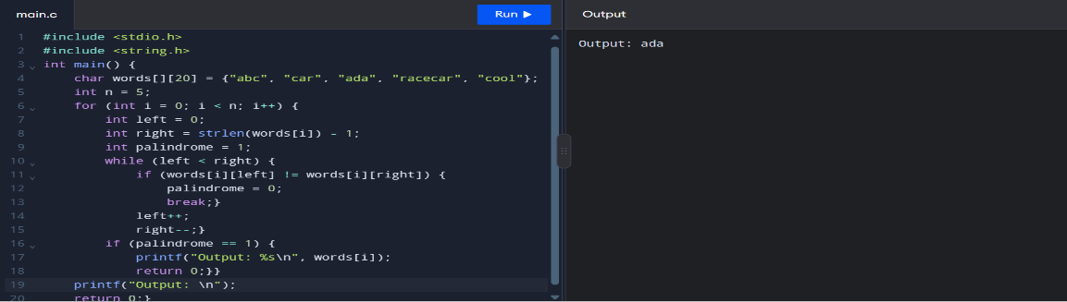
INPUT : words = ["abc", "car", "ada", "racecar", "cool"]
OUTPUT : ada
Time Complexity: O(n × m)
Space Complexity: O(1)
RESULT
Thus, the C program successfully finds and displays the first palindromic string in the given array.

2 Count Common Elements in Two Arrays
AIM
To find the number of elements in nums1 that exist in nums2, and the number of elements in nums2 that exist in nums1.
PSEUDOCODE
START
Read nums1 and nums2
Set answer1 = 0
Set answer2 = 0
FOR each element in nums1
Check if element exists in nums2
If yes, increase answer1
END FOR
FOR each element in nums2
Check if element exists in nums1
If yes, increase answer2
END FOR
Print answer1 and answer2
STOP
CODE
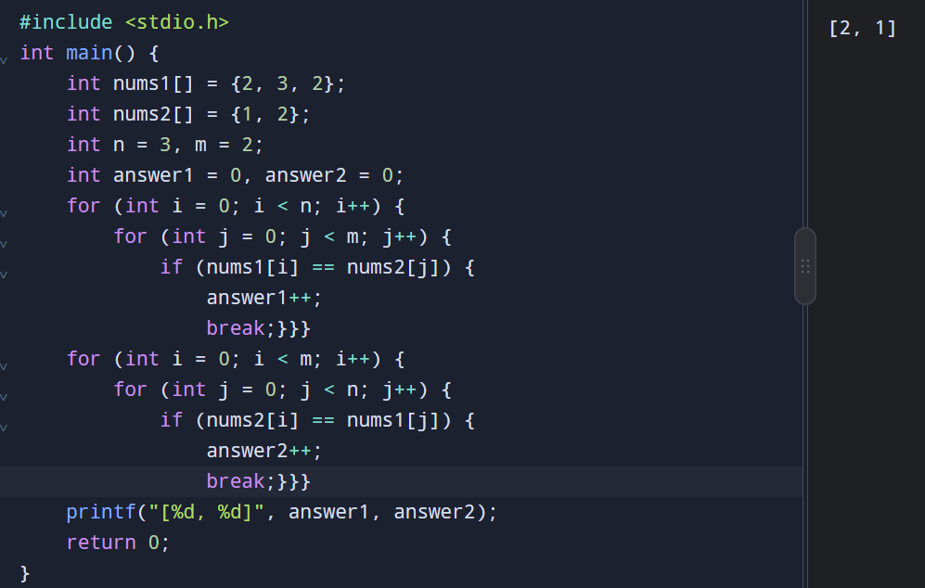
INPUT : nums1 = [2, 3, 2]
nums2 = [1, 2]
OUTPUT : [2, 1]
Time Complexity: O(n × m)
Space Complexity: O(1)
RESULT
Thus, the program successfully finds the number of elements in each array that also exist in the other array.

3 Sum of Squares of Distinct Counts
AIM
To find the sum of the squares of the number of distinct elements in all possible subarrays of a given array.
PSEUDOCODE
START
Read array nums
Set sum = 0
FOR i = 0 to n-1
Create an empty set of distinct elements
distinct = 0
FOR j = i to n-1
IF nums[j] is not already in the set
Add nums[j] to the set
Increase distinct by 1
END IF
sum = sum + distinct × distinct
END FOR
END FOR
Print sum
STOP
CODE

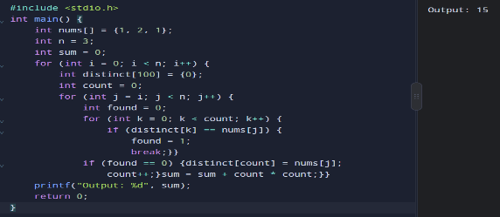
INPUT : nums = [1, 2, 1]
OUTPUT : 15
Time Complexity: O(n³)
Space Complexity: O(n)
RESULT
Thus, the program successfully calculates the sum of squares of distinct counts of all subarrays.

4 Count Equal Pairs Divisible by K
AIM
To find the number of pairs (i, j) where nums[i] == nums[j] and (i × j) is divisible by k.
PSEUDOCODE
START
Read nums and k
Set count = 0
FOR i = 0 to n-1
FOR j = i+1 to n-1
IF nums[i] == nums[j] AND (i × j) % k == 0
count = count + 1
END IF
END FOR
END FOR
Print count
STOP
CODE :
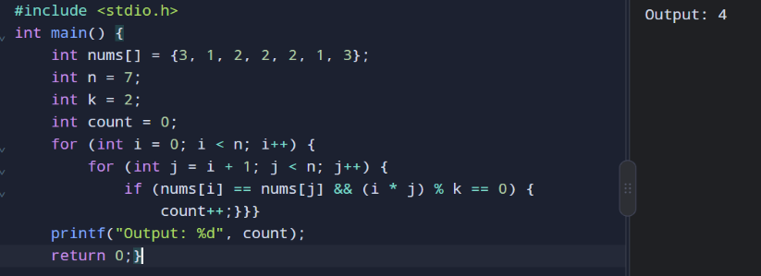
INPUT
nums = [3, 1, 2, 2, 2, 1, 3]
k = 2
OUTPUT : 4
Time Complexity: O(n²)
Space Complexity: O(1)
RESULT
Thus, the program successfully finds the number of valid pairs satisfying both conditions.

5 Find the Maximum Element in an Array
AIM
To write a C program to find the largest element in an array using the least time complexity.
C CODE
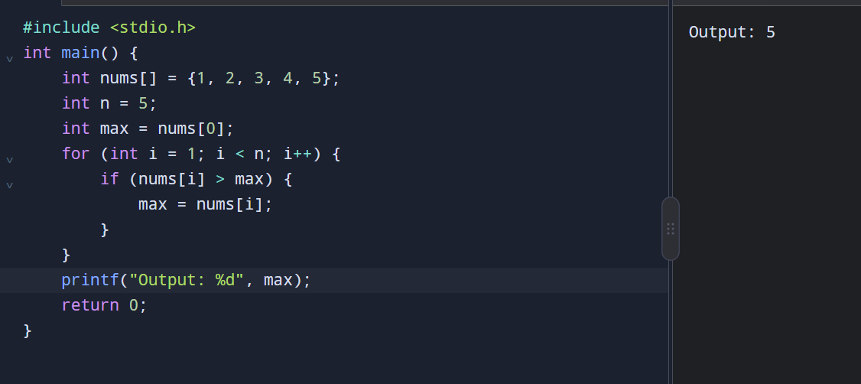

Input:
{1, 2, 3, 4, 5}
Output:
5
Time Complexity: O(n) | Space Complexity: O(1)
RESULT
Thus, the program successfully finds the largest element in the array using a single traversal.

6 sorts a list using an efficient sorting algorithm
AIM
To write a C program that sorts a list using an efficient sorting algorithm and then finds the maximum element from the sorted list.
PSEUDOCODE
START
Read the list
IF list is empty
Print "List is empty"
STOP
END IF
Sort the list using Quick Sort
Maximum = last element of sorted list
Print Maximum
STOP
CODE
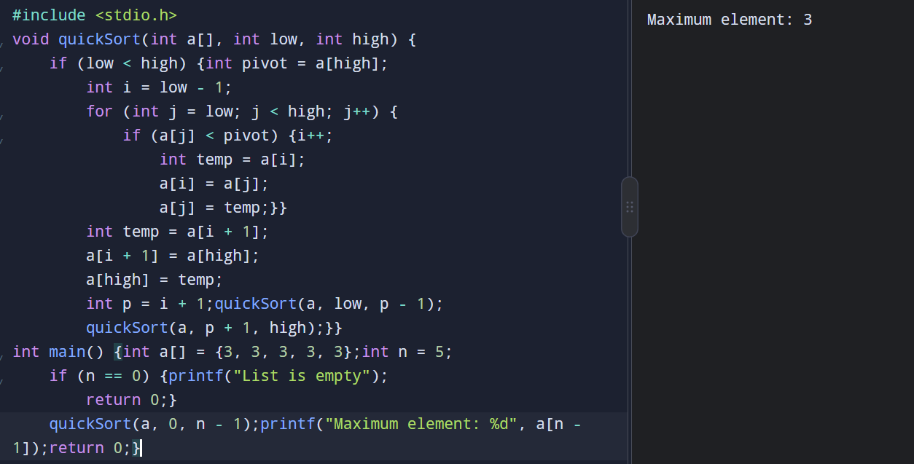
Input:
[]
Output:
List is empty
Time Complexity: O(n log n) average | Space Complexity: O(log n) average
RESULT
Thus, the program successfully sorts the list using Quick Sort and finds the maximum element from the sorted list.

7 Find and print unique elements in an array.
AIM
Write a C program to create a new list containing only the unique elements from the given list.
PSEUDOCODE
START
Read n and array
Create a new array
FOR each element
Check if it already exists in new array
If not, add it
Print new array
STOP
CODE
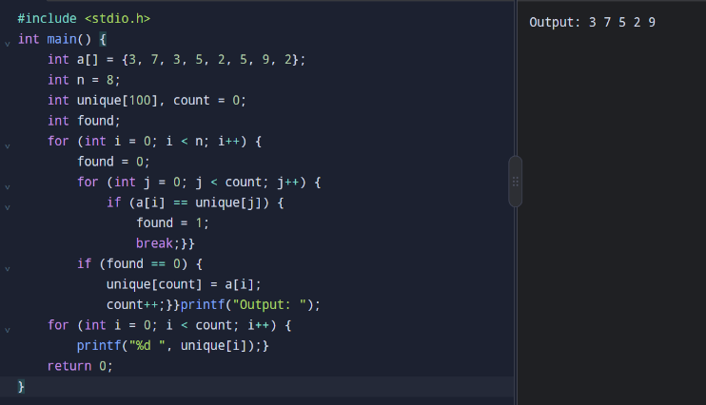
Input: [-1, 2, -1, 3, 2, -2]
Output: [-1, 2, 3, -2]
Time Complexity: O(n²) | Space Complexity: O(n)
RESULT
The program successfully creates a new list containing only the unique elements.

8 Bubble Sort
AIM
To sort an array of integers in ascending order using the Bubble Sort technique and analyze its time complexity.
CODE
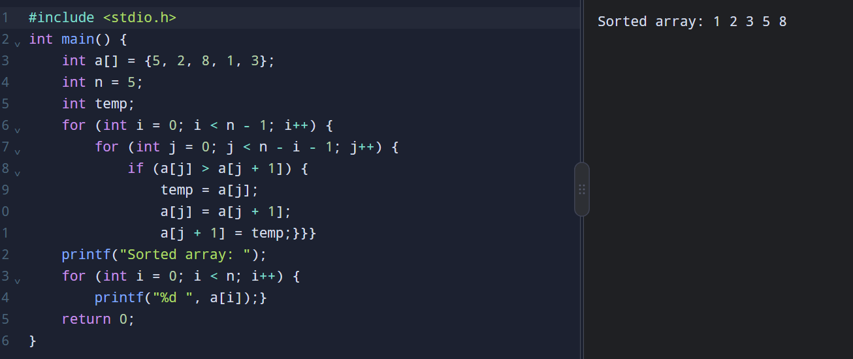

INPUT
[5, 2, 8, 1, 3]
OUTPUT
Sorted array: 1 2 3 5 8
Time Complexity: O(n²) | Space Complexity: O(1)
RESULT
The array is successfully sorted in ascending order using Bubble Sort.

9 Binary Search in C

AIM
To write a C program to search for a given element in an array using the binary search technique and analyze its time and space complexity.
Pseudocode
START
1. Read the array elements and key.
2. Set low = 0 and high = n - 1.
3. Repeat while low <= high:
a. Calculate mid = (low + high) / 2.
b. If arr[mid] == key:
Print the position and stop.
c. If key < arr[mid]:
Set high = mid - 1.
d. Otherwise:
Set low = mid + 1.
4. If the key is not found, print "Element not found".
STOP
C Program
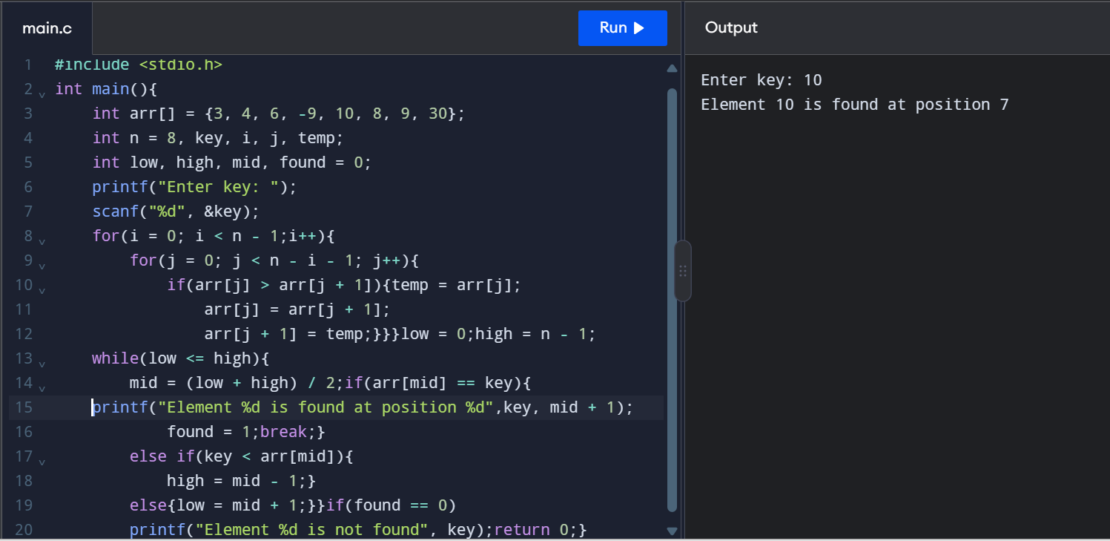
Input:
Enter key: 10
Output:
Element 10 is found at position 7
Time Complexity: O(n²),
Space Complexity: O(1).
Result
Thus, the C program to search for an element using binary search was implemented successfully, and its time and space complexities were analyzed.

10 Array Sorting Using Merge Sort
Aim
To write a C program to search for a given element in an array using the binary search technique and analyze its time and space complexity.
Pseudocode
START
1. Read the array elements and key.
2. Set low = 0 and high = n - 1.
3. Repeat while low <= high:
a. Calculate mid = (low + high) / 2.
b. If arr[mid] == key:
Print the position and stop.
c. If key < arr[mid]:
Set high = mid - 1.
d. Otherwise:
Set low = mid + 1.
4. If the key is not found, print "Element not found".
STOP
CODE
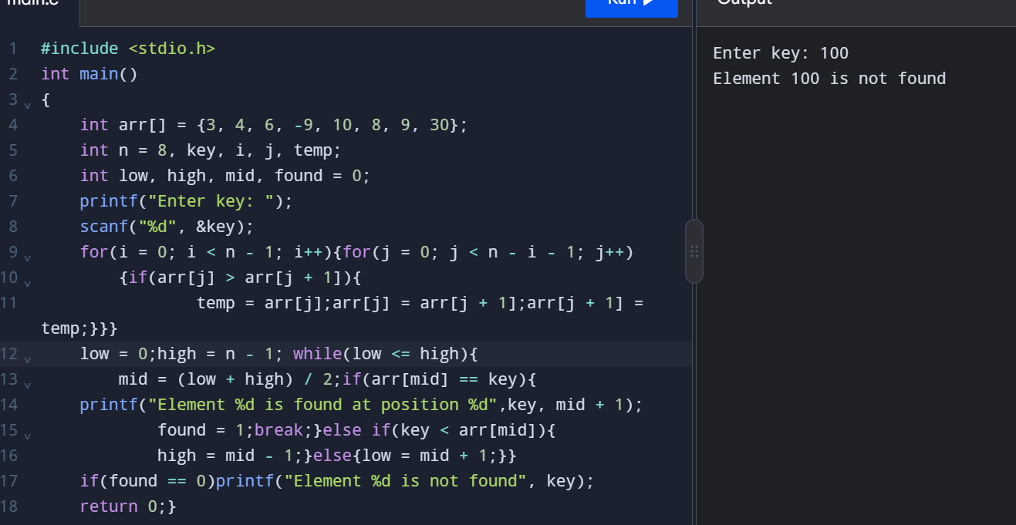

Input:
Enter key: 100
Output:
Element 100 is not found
Time Complexity: $O\left(n\log{n}\right)$in best, average, and worst cases.
Space Complexity: $O\left(n\right)$auxiliary space for merging, plus $O\left(\log{n}\right)$recursion stack space.
Result
The array is sorted in ascending order using Merge Sort without built-in sorting functions.

